Technical Workflow – Monday.com
After going over the user journeys, and the technical notes of the software, I have revised a workflow that Monday.com is using to receive and store data.
1. Form
Monday.com receives its raw data from forms linked to the spreadsheet, or board. Whether that form being for the “Main Telecoms” or the “Printers”, each board has it’s own form to receive data.
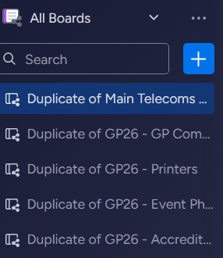
Within the form is a multitude of questions which relate directly to a column in the Monday.com spreadsheet service. For example, the form asks for the vendor’s “EMAC Number”. This number, from what I believe, is a primary data source, or a Primary Key, to differentiating the number of vendors.

After the required data text boxes are fulfilled, which can be identified by the “*”, the form then is translated into raw data for the spreadsheet, translating the answer given in the form into data for the columns in the spreadsheets on the board.

2. Results
After the data is successfully inputted through the form, the results are then categorized into their corrective columns, such as “EMAC Number” goes to the “EMAC” column. 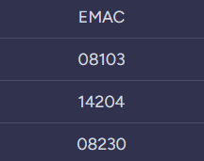

Not all results have been fulfilled with some being empty, or completely null. As seen in “Problems/Issues” there is no data here, meaning there was not a problematic form submitted by a vendor. 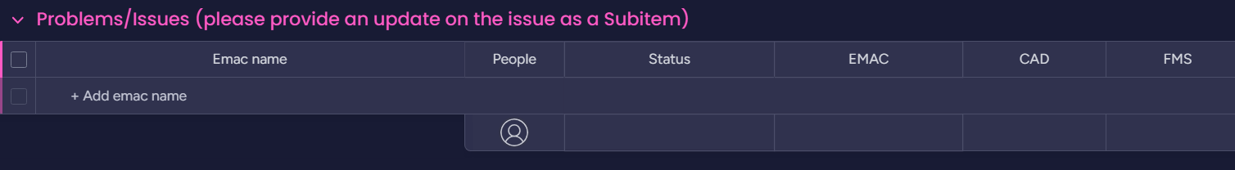
3. Status
Once the results have been categized automatically by the software, they then get redirected/sorted into the respective “Status”. That being, “EVT work completed”, “Rejected”, “In progress”, etc. This status allows for more differentiation between the datasets, as well as a more clearer vision of the board for the back-end users, such as data analysts and administrators for the Grand Prix.
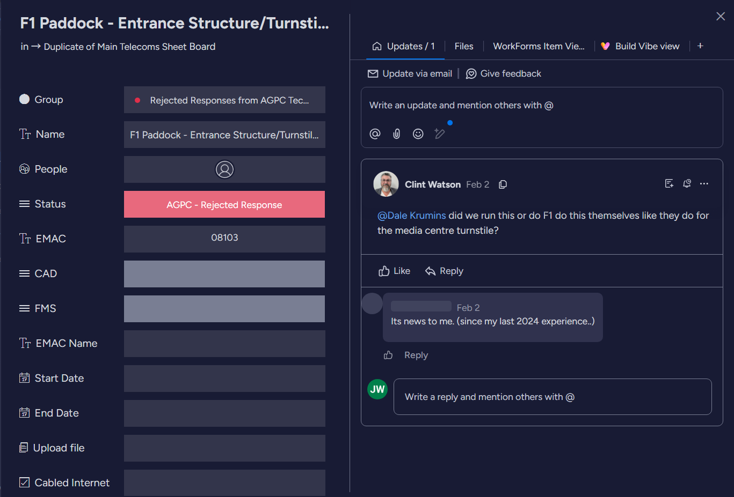
The status of form is done manually through the back-end of Monday.com through the administrators working with the Grand Prix, or F1.
The results are categorized by this status, having different spreadsheets/areas on the board for each kind of status.
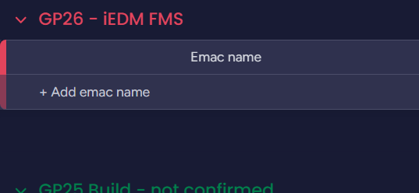

Notes (Areas of Optimization):

The first area of optimization I recorded was the names of the columns, for example there is two columns both named Emac name except one is in all caps and the other is not. This is a pretty flawed design for a database and could lead to confusion.
The second area of optimization is how the status of the form is being handled. If this was to be an LLM-assistance in this form instead, the statuses of the forms can be handled automatically through the LLM’s understanding of the form.
The third area of optimization would be the deletion, or reassessment of the redundant columns which houses minimal to no data in most datasets.
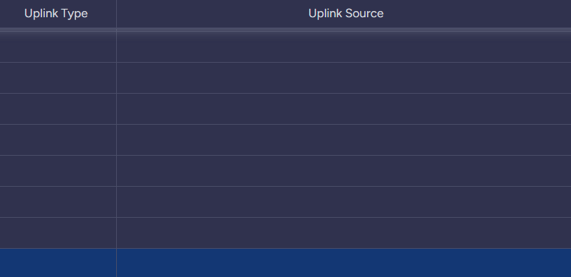
As seen, the Uplink Type and Uplink Source, are blank; and are only used on the completed datasets. Instead of the column being on every status area, the uplink type and source should be only present on the completed status datasets, to relieve stress on the board, and to clean up the datasets with massive blank columns. 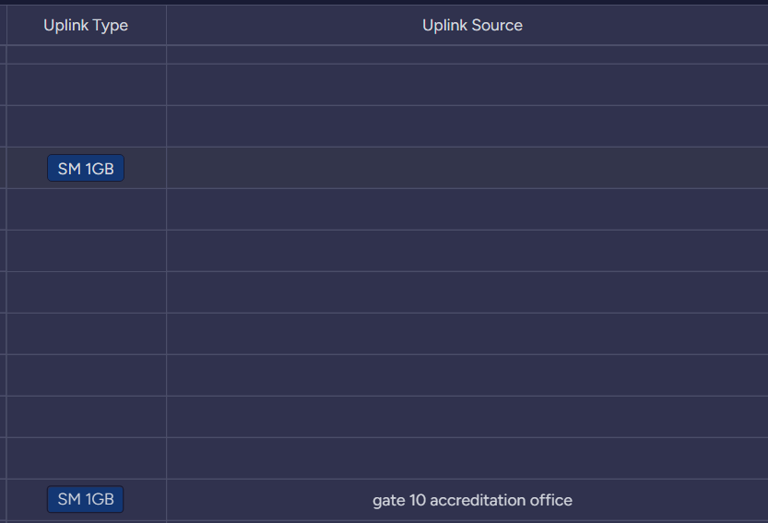

Diagram of the technical workflow:
